University of Waterloo

Department of Mechanical and Mechatronics Engineering

MTE 111

Lab 1: Elastic Properties of Cantilevered Beams

Prof. Yimin Wu

Group #23: Ian Jinzo Macpherson Takeda, Joe Chen, Pedro Brossel, Randy Jayasinghe

June 9th, 2023

**SUMMARY:**

This experiment was conducted to calculate the modulus of elasticity of pine wood (along the grain), 6061-T6 wrought aluminum alloy, and AISI 1018 cold-rolled low-carbon mild steel. The measurements were conducted in an apparatus that stabilized the three beams, cantilevering them over an edge. Then weights were added progressively to the other side of each beam to measure its deflection under a known load.

The first step was to measure the masses and dimensions of the three beams, as well as the masses that were to be added on to cause deflection. To accurately collect the data, a ruler was used to measure each beam’s deflection under different masses. An Excel sheet was then used to record the measured data, as well as construct related and useful graphs and tables.

After the experiment, it was concluded that AISI 1018 cold-rolled low-carbon mild steel had the steepest load-deflection gradient, and the sample of pine wood (along the grain) had the least steep. Using this conclusion and further calculations, it was discovered that mild steel had the largest elastic modulus of the three materials, followed by the aluminum alloy and the pine wood. The differences between the theoretical and calculated values obtained for different material properties (such as elastic modulus) were compared, and possible sources of error were discussed. Further, the three materials were evaluated and ranked in terms of suitability for different real-life applications. Finally, speculations were made as to which material would deflect the most under a known applied load if the linear dimensions of each beam were changed.

**INTRODUCTION:**

In industry, different types of materials are used for different situations, based on their properties and how well those properties are suited for the application. As such, the purpose of this lab was to compare how three different materials (pine wood, aluminum alloy, and mild steel) behaved when point loads were applied to them under their elastic limits.

By completing this lab, the objective was to determine several properties of these materials, including the elastic modulus, specific modulus, specific strength,and relative stiffness of each material, and compare the obtained values in order to make decisions on the best types of materials to be used in varying scenarios. This report aims to detail the processes by which data was gathered and processed, as well as provide information regarding the conclusions reached as to which types of materials would be best used for particular situations.

Additionally, the evaluation of the gathered data will include comparisons between the obtained experimental values and the corresponding theoretical values.

**EXPERIMENTAL PROCEDURE:**

1. Measurement of materials: The pieces of pine wood, mild steel and aluminum alloy had each linear dimension (length, width, and thickness) measured from three points along the beam, and the average of the three values was calculated and logged. This was done to account for the fluctuations in each dimension along the beam. Then, each beam and load were weighed and had their mass recorded.
2. Setup: Using the provided apparatus, each beam was placed in the specified slot and held in place by the gripper (see Fig. 1). Then, using a large flat metal block as a base, a ruler was placed directly behind the opposite end of the beam, in order to measure the deflection of the material. A hook was used to load weights and was placed through a hole drilled through the material to hold it in place. Finally, for each material, the initial deflection (without any weights) was recorded.

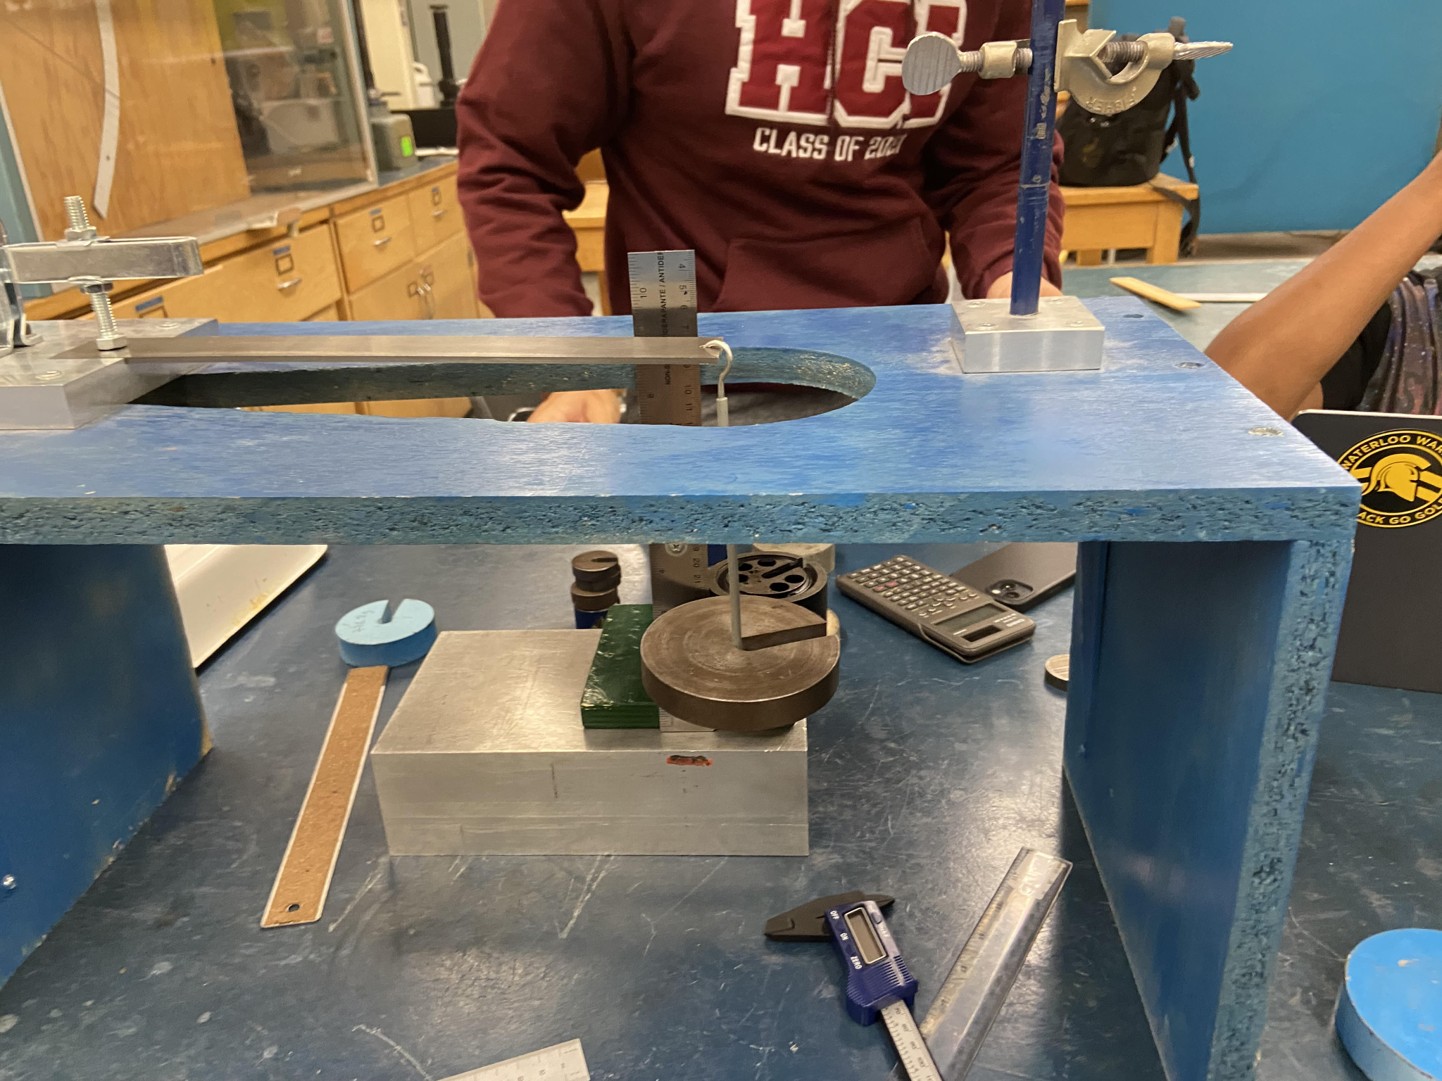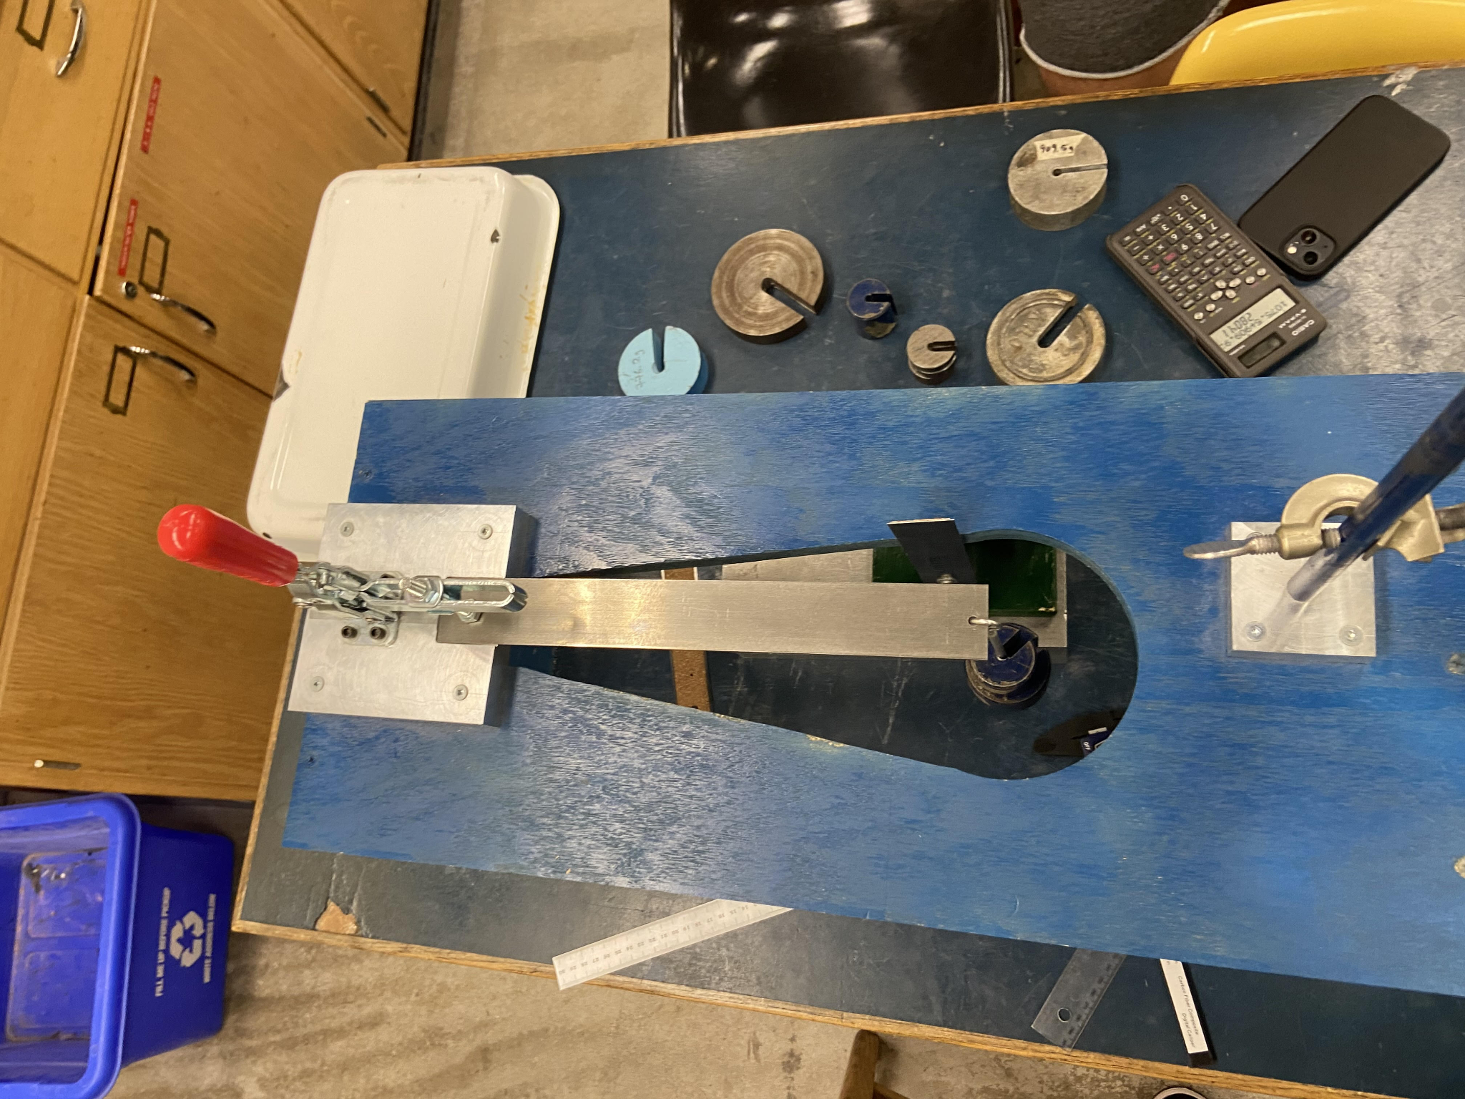



1. Pine wood: 10 different weights within a range of 72.8 to 1075.5 grams with increments of roughly ~90 grams were used and the deflection was recorded.
2. 6061-T6 Aluminum alloy: A similar procedure to that used with pine wood was used for this material. However, the range of loaded masses was 181 to 1894.2 grams with an average of ~170 gram increments for each measurement.
3. AISI 1018 Mild steel: Once again, 10 measurements were taken using an even larger range of load masses from 289.4 to 2804.1 grams with an average of a ~250g increase per measurement.

**RESULTS:**

| **Material** | **Mass(g)** | **Effective Length**  **(mm)** | **Width**  **(mm)** | **Thickness**  **(mm)** | **Volume**  **(mm3)** | **Density**  **(kg/m3)** | **Second moment of area**  **(m4)** |
| --- | --- | --- | --- | --- | --- | --- | --- |
| Pine wood | 24.10 | 261.02 | 38.40 | 4.43 | 51876.61 | 464.56 | 1.42 x 10-11 |
| 6061-T6 Wrought Aluminum Alloy | 98.90 | 303.47 | 38.06 | 2.91 | 38641.77 | 2559.41 | 9.24 x 10-12 |
| AISI 1018 Cold-Rolled Low Carbon Steel | 283.70 | 311.77 | 38.11 | 2.89 | 38205.26 | 7425.68 | 9.18 x 10-12 |

Table 1: details of measurements taken during the experiment (i.e. dimensions and mass) as well as calculated values relating to those dimensions (density and second moment of area)

In addition to the steps taken in the Experimental Procedure to measure and record the values found in Table 1, the effective length of each beam was calculated by subtracting the length of the bar in the slot (see step 2 of the Experimental Procedure section) as well as the distance from the far end of the beam to the edge of the hole nearest to the slotted part of the bar. These values were then recorded to be used in further calculations.

To calculate the volume of each beam, care was taken to account for the hole drilled out of one end (used to hold the hook, as mentioned in the Experimental Procedure). Its volume was calculated and then subtracted from the theoretical volume of the beam.

To calculate the second moment of area, the given equation ($I=\frac{wt^{3 }}{12 }$) was used, along with the calculated average values for width (w) and thickness (t).

| **Materials** | **Density (kg/m3)** | **Yield Strength (MPa)** | **Elastic Modulus (GPa)** | **Specific Modulus (GPa/Kg)** | **Specific Yield Strength (Pam3/kg)** |
| --- | --- | --- | --- | --- | --- |
| Pine wood | 440-600 | 35-45 | 8.4-10.3 | 0.014-0.023 | 0.058-0.102 |
| 6061-T6 Wrought Aluminum Alloy | 2670-2840 | 241-520 | 68-76 | 0.023-0.028 | 0.085-0.195 |
| AISI 1018 Cold-Rolled Low Carbon Steel | 7800-7820 | 255-355 | 200-220 | 0.026-0.028 | 0.033-0.046 |

Table 2: details of published (i.e. theoretical) values (ranges) for properties such as density, yield strength, specific and elastic moduli, and specific yield strength

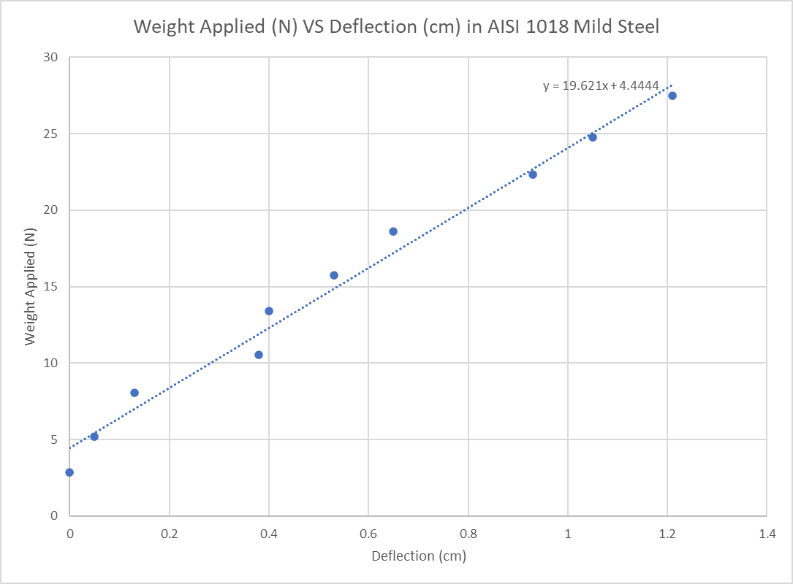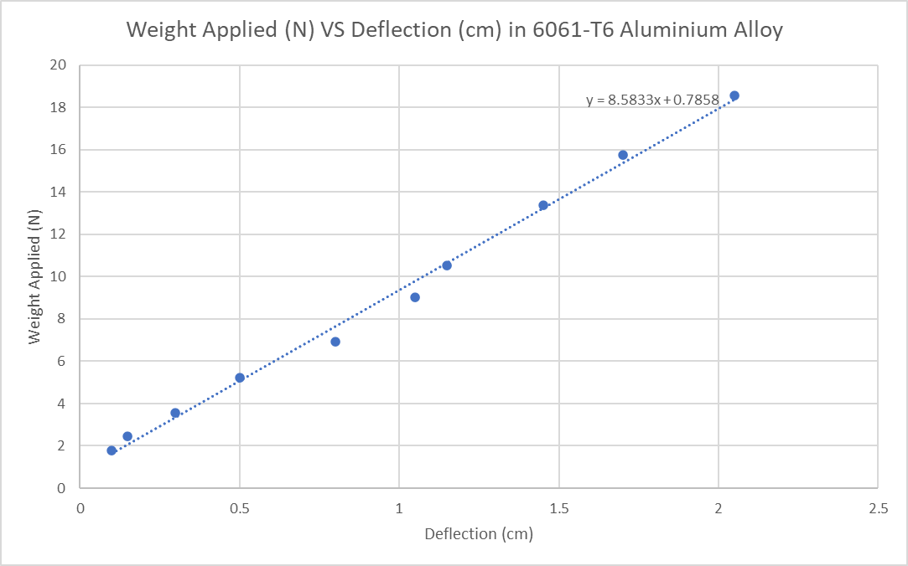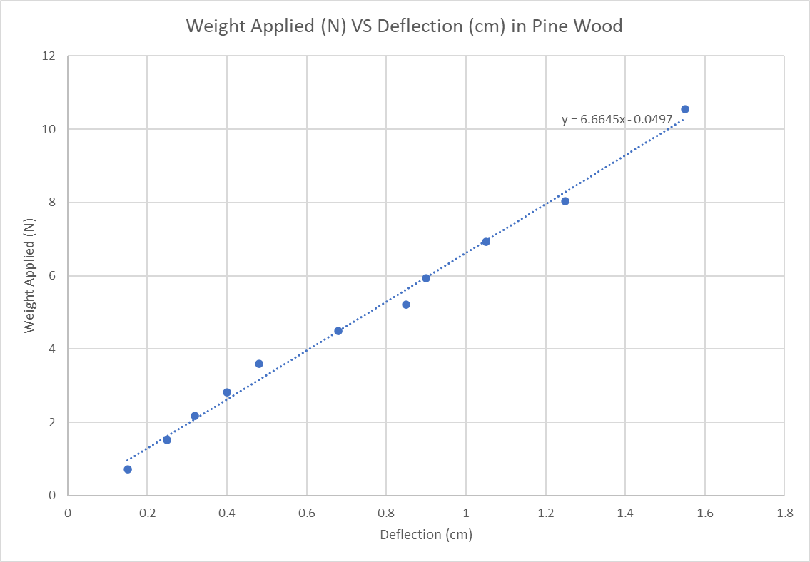



Figures 3-5 above show the lines of best fit (or trendlines) of a load-deflection curve for each of the three materials. 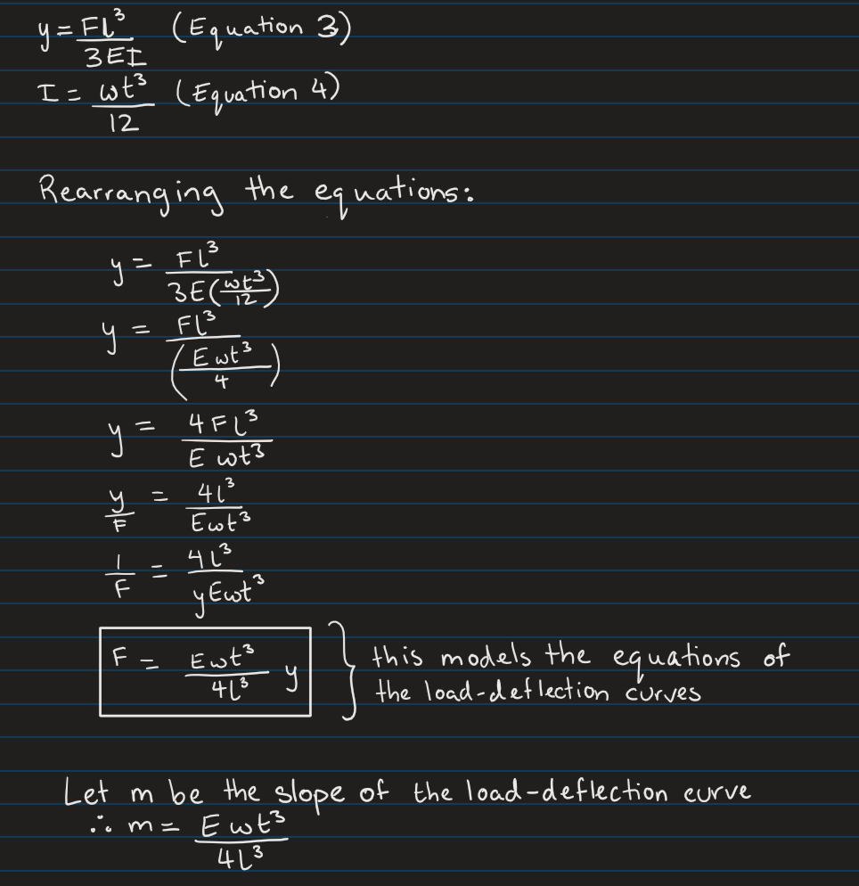



Fig. 6 details the preliminary working done before calculating the elastic modulus of each material. To begin, Equation 3 and 4 (provided prior to the experiment) were combined and rearranged to model the general equation of a straight line (i.e. y = mx + b). This was done to allow equating the coefficient of y (the deflection) to the slope of the plotted graphs.

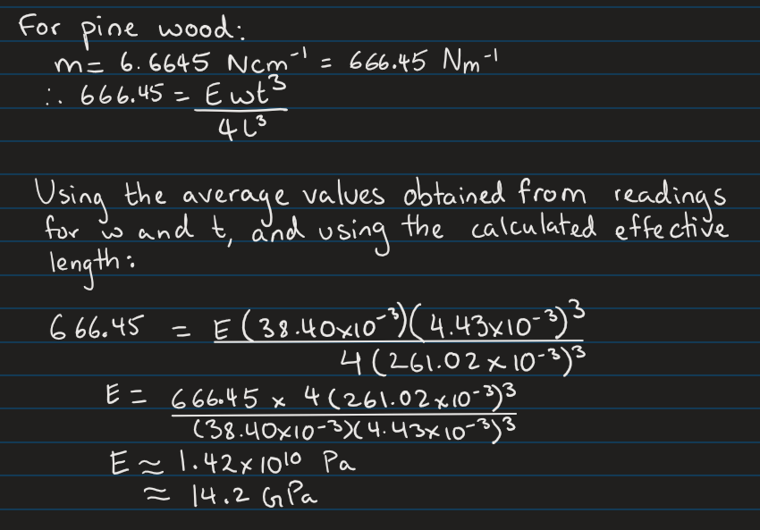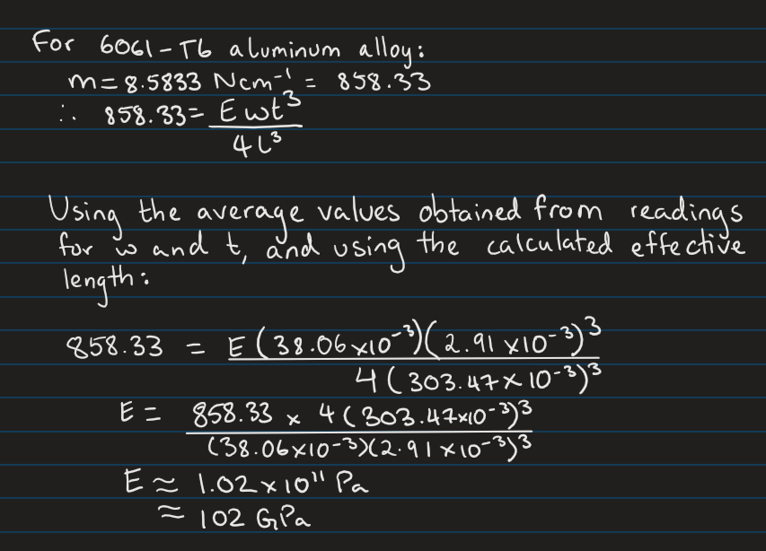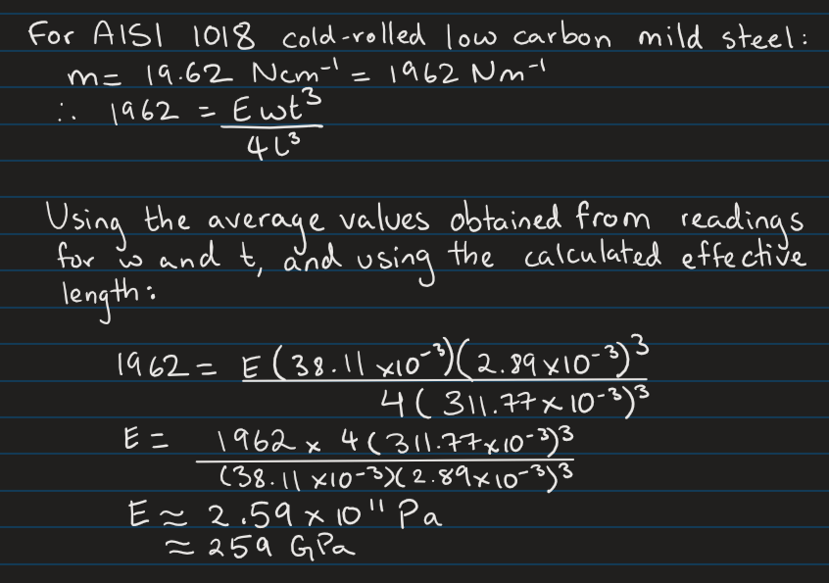



Figures 7-9 show the process used to calculate the elastic modulus of each material. As detailed in the figures, the average values of the width and thickness of each beam (see Table 1) were used, as well as the effective lengths of each beam.

**DISCUSSION:**

Comparing Load-Deflection Curves:

The order of magnitudes of the load-deflection gradients for the three materials were as follows: mild steel (19.62 N/cm) (Fig. 4), aluminum alloy (8.58 N/cm) (Fig. 5) and pine wood (6.66 N/cm) (Fig. 3).

As is evident, mild steel had the largest gradient of the three. This means that of the three materials, the steel beam needed the heaviest load to deflect per centimeter. This is further corroborated by steel having the largest value of elastic modulus of the three materials (approximately 259 GPa) (see Fig. 9).

By contrast, pine wood had the lowest gradient on its load-deflection graph, meaning it deflected the most under a certain load out of the three materials, so it was the least resistant to elastic deformation. This conclusion is further proved by the sample of pine wood used in the experiment having the lowest elastic modulus value of the three (approximately 14.2 GPa).

Accuracy of Equation 3 In Predicting Beam Behavior:

According to Equation 3 ( $y=Fl^{3}/(3EI)$), the deflection of the beam is directly proportional to the force applied to it since the second moment of area, modulus of elasticity, and effective length remain the same throughout the procedure. Therefore, the Weight Applied vs. Deflection graph should have a linear relationship, starting at the origin, with a positive slope of $Ewt^{3}/(4l^{3})$ (Fig. 6). Analysing the experimental graphs (figures 1-3), the line of best fit is given in the form y = mx + b. The y-intercept values present on the experimental graphs is not acconuted for by equation 3 and can be explained by errors in measurements when dealing with small loads and deflections. Therefore, the ability of equation 3 to predict the behaviour of the beams will be relative to the discrepancy between the expected slope (from published values) and the actual slope of the graph.

After calculating the theoretical slope of the line, $Ewt^{3}/(4l^{3})$, using the elastic modulus range (Table 2) for each material, as well as the measured width, length, and thickness (Table 1), a theoretical range for the slope can be calculated. The resulting range of values for each beam are 15.18-16.70 N/cm for steel, 5.70-6.38 N/cm for aluminum, and 3.94-4.83 N/cm for pine wood. These values are 38.0%, 34.5%, and 17.5% lower than the experimental slope values (Figures 3-5) for pine wood, aluminum, and steel, respectively. There are two main potential causes for the high percentage error. Firstly, the variation in critical measurements such as thickness or length could lead to dramatic deviations from the theoretical values (since these measurements are cubed). In addition, the materials could have been used before for other experiments, which could have impacted their elasticity.

Overall, Equation 3 predicts a linear relationship, which was found experimentally. However, it fails to predict the larger slope values and the presence of a non-zero y-intercept (“b” value), for the reasons discussed previously.

Comparing Calculated and Published Values for Elastic Moduli:

| **Material** | **Calculated Elastic Modulus (GPa)** | **Published Range for Elastic Modulus (GPa)** | **Percentage Difference Between Calculated Value and Upper End of Published Range (%)** |
| --- | --- | --- | --- |
| Pine wood | 14.2 | 8.4 - 10.3 | 37.9 |
| Aluminum alloy | 102 | 68 - 76 | 34.2 |
| Mild steel | 259 | 200 - 220 | 17.7 |

Table 3: Comparison of calculated and published values for elastic modulus of each material

Out of the three experiments, the evaluation done for the elastic modulus of pine wood yielded the largest percentage error (37.9%) (see Table 3). Along with human error in measurement (even though measurements were taken from three different points and an average was taken for each dimension, this still leaves room for error), a possible reason for the discrepancy is the organic nature of material. Even if the beam was cut to size using power tools, the measurements for width and thickness taken would not be as accurate as possible due to the uneven surface of the wood beam.

For the other two materials, their nature plays a smaller role in the discrepancies since they are easier to shape into close-to-perfect rectangular prisms (this claim is further corroborated by the similarities in the measured width and thickness values for the steel and aluminum beams (see Table 1)). This correlates to the fact that the percentage errors for both materials were less than that of pine wood. However, especially since the width and thickness values were raised to the power 3 in the calculations for elastic modulus (see Figures 7-9), any error in measurement for each dimension would be magnified, thus contributing to the discrepancy between the calculated and published values.

Comparing Beam Properties and Evaluating for Real-Life Applications:

In terms of the mass and the density of the three materials, mild steel has the highest, followed by aluminum alloy and pine wood. For the elastic modulus (E) of the three materials, mild steel has a range of 200-220 GPa, aluminum alloy has 68-76 GPa and pine wood has 8.4-10.3 GPa. For specific stiffness, mild steel has a range of 0.026-0.028, aluminum alloy a range of 0.023-0.028 and pine wood has the lowest range of 0.014-0.023. (Refer to Table 2 for the published values). - just say which is bigger/smaller

1. When evaluating an unsupported balcony, there must not be an excessive deflection. Therefore, the specific stiffness (calculated using the elastic modulus of the material divided by its density) for the three materials is the most important material property. Since the calculation for stiffness is inversely proportional to density, the lower the material’s density, the higher its specific stiffness. The higher the elastic modulus of a material, the less deflection it shows when a force is applied and the higher its specific stiffness. However, since the unsupported balcony’s specific stiffness is the most critical property, mild steel has the largest value for specific stiffness which makes it the most suitable material followed by aluminum alloy and pine wood.
2. When evaluating an aircraft wing, it must never fail under load. Therefore, the specific strength of the material is the most important property for this application. Specific strength is measured and calculated using the yield stress of the material divided by its density. Because mass and density are both inversely proportional to the specific strength, the higher the values of both properties, the lower the specific strength. In terms of the specific stiffness and elastic modulus, both properties are not a main factor for an aircraft wing to never fail under load. However, the yield strength and the density of the materials are essential for the calculation of the specific strength. The calculated specific strength for mild steel is 0.033-0.046, aluminum alloy is 0.085-0.195 and pine wood is 0.058-0.102. Since the specific strength of the aircraft is the most important property, aluminum alloy is the most suitable material as it has the highest specific strength, followed by pine wood and mild steel.

Calculations on Masses and Deflections of Wood Compared to Steel: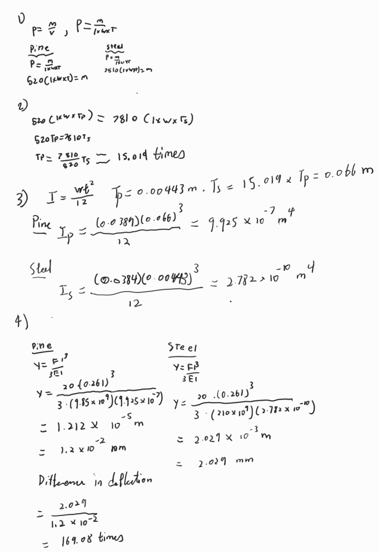



1. The length and width of both beams must be the same to keep the experiment fair
2. By setting the density equations equal to each other, the thickness for pine wood must be 15 times greater than the thickness of steel.
3. Deflection can be calculated for both materials.
4. Therefore, if the mass of the pine wood and steel are the same, mild steel will deform 169.08 times more than pine wood when supplied with 20 N.

**CONCLUSION:**

To summarize the findings of this experiment, the beam of mild steel was found to have the highest elastic modulus (259 GPa), followed by aluminum alloy (102 GPa) and then pine wood (14.2 GPa). This follows the readings from the experiments, wherein it was found that pine wood had the most overall deflection due to a load, followed by aluminum alloy and then mild steel.

Comparisons were made between the theoretical and calculated values, and it was found that the experimental values resembled the expected theoretical ones within a reasonable margin of error, including the general trends in material properties. Upon further comparison, the predicted linear relationship held true in the experiment. However, the theoretical slope was lower than the experimental one. Additionally, different applications of the materials were discussed based on their respective purposes and scenarios, where several properties of the three materials were taken into account, and decisions were made as to the suitability of each material for specific purposes.

**REFERENCES:**

1. CES EduPack 2021, Granta Design Ltd., Cambridge, UK. This materials database and materials selection software is available to you.
2. R.C. Hibbeler, Mechanics of Materials, 6th ed., Pearson Prentice Hall, Upper Saddle River, New Jersey,USA, 2005
3. “Physics - young’s modulus,” University of Birmingham, https://www.birmingham.ac.uk/teachers/study-resources/stem/physics/youngs-modulus.aspx#:~:text=The%20Young’s%20modulus%20(E)%20is,%CE%B5%20%3D%20dl%2Fl). (accessed Jun. 13, 2023).